 | X8 Physical Node 1 |  | X8 Physical Node 2
ORAX8DEV1 - 10.120.1.28 | 6 | ORAX8DEV2- 10.120.1.27 | 6
ORAX8PPD1 - 10.124.1.20 | 2 | ORAX8PPD1 - 10.124.1.21 | 2
ORAX8DR1 - 10.110.1.10 | 2 | ORAX8DR2 - 10.110.1.11 | 2

10.113.1.55 ovmdr.mcb.local
10.113.1.110 x8ora1ppd
10.113.1.111 x8ora2ppd

Storage Team - Storage Disk Allocation
Dear Team,Dear Team,
Please provide the following LUNs
Hostname | Host IP | Lun Size | Quantity | Storage name
OVS1 & OVS 2 | 10.113.1.110  10.113.1.111 | 1TB | 1

1TB 1 ORAX8DEV-MFTDATADG
WWN
Node 1 - x8ora1ppd
0x100000109b21c0ea
0x100000109b21c0eb
Node 2 - x8ora2ppd
0x100000109b21c08d
0x100000109b21c08e
Hostname | Host IP | Lun Size | Quantity | Storage name
OVS1 & OVS 2 | 10.113.1.110  10.113.1.111 | 1TB | 1
ORAX8DEV-CAMUNDAPPD 5782700000143

OVM

Connect on DRADMINUNIX02

--SCAN LUNS on EXADATA Physical Nodes

10.113.1.55 ovmdr.mcb.local
10.113.1.110 x8ora1ppd
10.113.1.111 x8ora2ppd

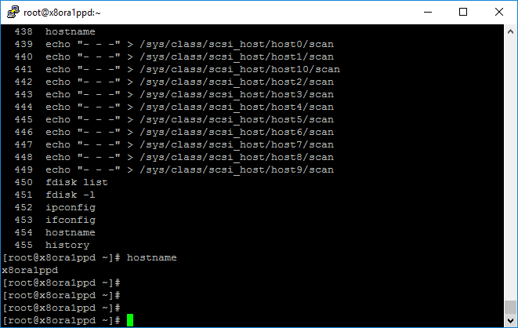

root/root123
hostname
echo "- - -" > /sys/class/scsi_host/host0/scan
echo "- - -" > /sys/class/scsi_host/host1/scan
echo "- - -" > /sys/class/scsi_host/host10/scan
echo "- - -" > /sys/class/scsi_host/host2/scan
echo "- - -" > /sys/class/scsi_host/host3/scan
echo "- - -" > /sys/class/scsi_host/host4/scan
echo "- - -" > /sys/class/scsi_host/host5/scan
echo "- - -" > /sys/class/scsi_host/host6/scan
echo "- - -" > /sys/class/scsi_host/host7/scan
echo "- - -" > /sys/class/scsi_host/host8/scan
echo "- - -" > /sys/class/scsi_host/host9/scan

[root@x8ora1ppd ~]# lsblk | grep -i 5782700000143
└─36c8b6d3100a0f2f403c5782700000143 (dm-596) 249:596 0 1T 0 mpath
└─36c8b6d3100a0f2f403c5782700000143 (dm-596) 249:596 0 1T 0 mpath
└─36c8b6d3100a0f2f403c5782700000143 (dm-596) 249:596 0 1T 0 mpath
└─36c8b6d3100a0f2f403c5782700000143 (dm-596) 249:596 0 1T 0 mpath

[root@x8ora2ppd ~]# lsblk | grep -i 5782700000143
└─36c8b6d3100a0f2f403c5782700000143 (dm-597) 249:597 0 1T 0 mpath
└─36c8b6d3100a0f2f403c5782700000143 (dm-597) 249:597 0 1T 0 mpath
└─36c8b6d3100a0f2f403c5782700000143 (dm-597) 249:597 0 1T 0 mpath
└─36c8b6d3100a0f2f403c5782700000143 (dm-597) 249:597 0 1T 0 mpath

Internet Explorer : https://10.113.1.55:7002/ovm/console/faces/login.jspx
