http://server_name:port
it commes fast
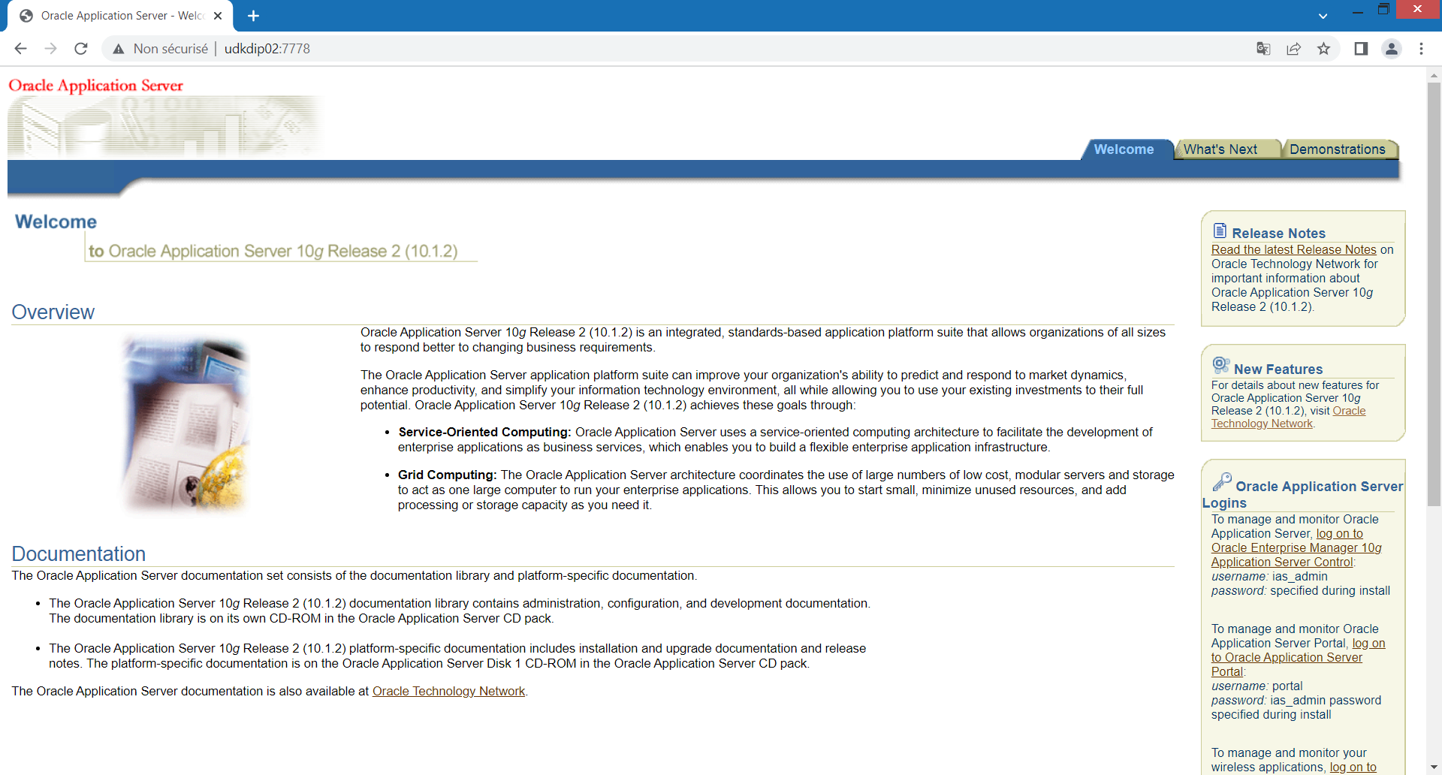
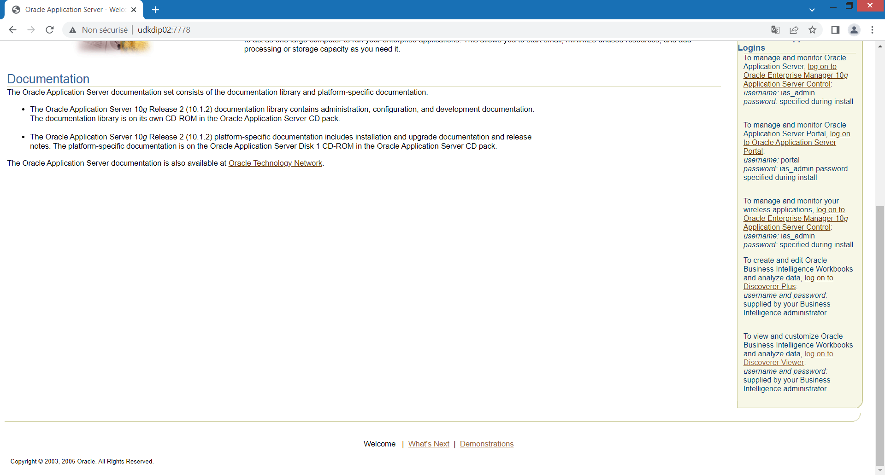
When we Clic on « log on to Discoverer Viewer » it takes long time to reply (or it crashs like this):
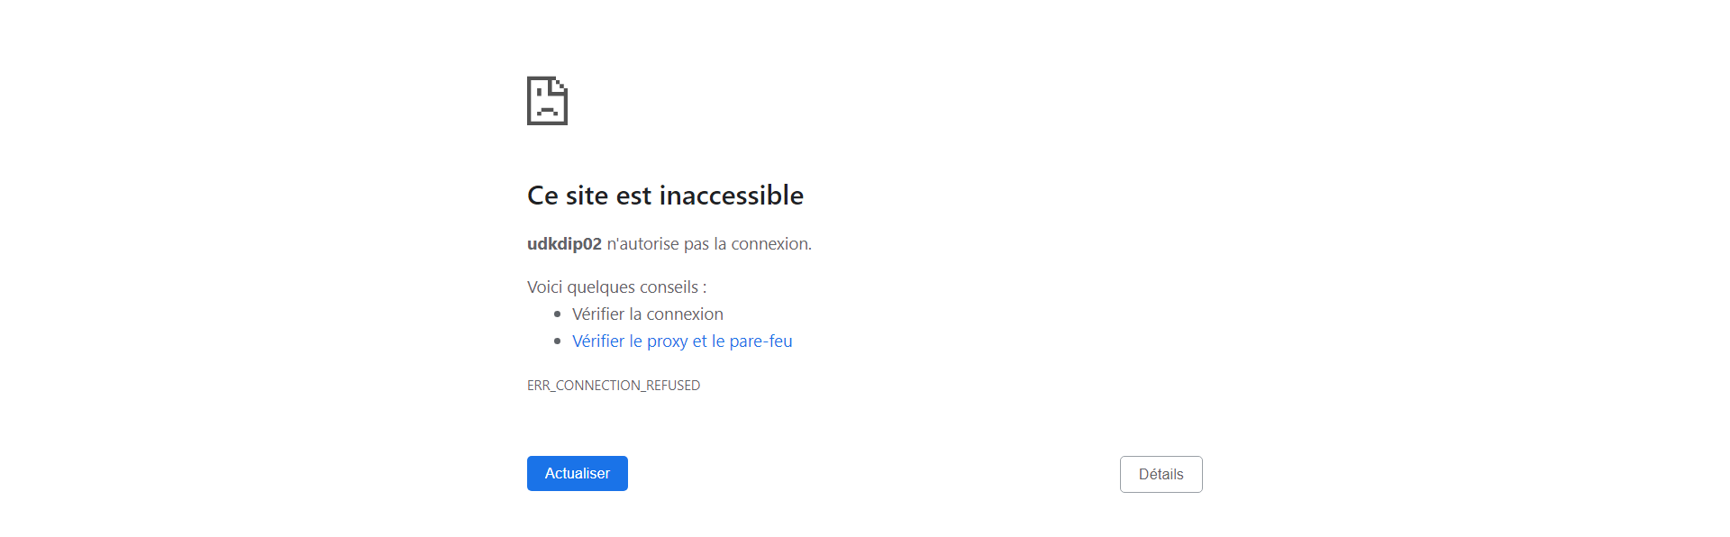
The ipm.log shows this :
23/08/31 15:29:37 [4] [libopmnwc] Process Ping Failed: WebCache~WebCache~WebCache~1 (341092518:7743) [The connection SSL receive timed out]
23/08/31 15:30:27 [4] [libopmnwc] Process Ping Failed: WebCache~WebCache~WebCache~1 (341092518:7743) [The connection SSL receive timed out]
23/08/31 15:31:17 [4] [libopmnwc] Process Ping Failed: WebCache~WebCache~WebCache~1 (341092518:7743) [The connection SSL receive timed out]
23/08/31 15:31:17 [4] [libopmnwc] Process Unreachable: WebCache~WebCache~WebCache~1 (341092518:7743)
23/08/31 15:31:19 [4] Stopping Process: WebCache~WebCache~WebCache~1 (341092518:7743)
23/08/31 15:31:35 [4] Starting Process: WebCache~WebCache~WebCache~1 (341092518:0)
23/08/31 15:31:36 [4] Process Alive: WebCache~WebCache~WebCache~1 (341092518:8423)
23/08/31 15:34:25 [4] [libopmnwc] Process Ping Failed: WebCache~WebCache~WebCache~1 (341092518:8423) [The connection SSL receive timed out]
23/08/31 15:35:15 [4] [libopmnwc] Process Ping Failed: WebCache~WebCache~WebCache~1 (341092518:8423) [The connection SSL receive timed out]
23/08/31 15:36:05 [4] [libopmnwc] Process Ping Failed: WebCache~WebCache~WebCache~1 (341092518:8423) [The connection SSL receive timed out]
23/08/31 15:36:05 [4] [libopmnwc] Process Unreachable: WebCache~WebCache~WebCache~1 (341092518:8423)
23/08/31 15:36:07 [4] Stopping Process: WebCache~WebCache~WebCache~1 (341092518:8423)
23/08/31 15:36:23 [4] Starting Process: WebCache~WebCache~WebCache~1 (341092518:0)
23/08/31 15:36:23 [4] Process Alive: WebCache~WebCache~WebCache~1 (341092518:8752)
23/08/31 15:37:13 [4] [libopmnwc] Process Ping Failed: WebCache~WebCache~WebCache~1 (341092518:8752) [The connection SSL receive timed out]
23/08/31 15:37:13 [4] [libopmnwc] Process Unreachable: WebCache~WebCache~WebCache~1 (341092518:8752)
23/08/31 15:37:15 [4] Stopping Process: WebCache~WebCache~WebCache~1 (341092518:8752)
23/08/31 15:37:31 [4] Starting Process: WebCache~WebCache~WebCache~1 (341092518:0)
23/08/31 15:37:32 [4] Process Alive: WebCache~WebCache~WebCache~1 (341092518:8809)
23/08/31 15:38:21 [4] [libopmnwc] Process Ping Failed: WebCache~WebCache~WebCache~1 (341092518:8809) [The connection SSL receive timed out]
23/08/31 15:38:21 [4] [libopmnwc] Process Unreachable: WebCache~WebCache~WebCache~1 (341092518:8809)
23/08/31 15:38:23 [4] Stopping Process: WebCache~WebCache~WebCache~1 (341092518:8809)
23/08/31 15:38:39 [4] Starting Process: WebCache~WebCache~WebCache~1 (341092518:0)
23/08/31 15:38:40 [4] Process Alive: WebCache~WebCache~WebCache~1 (341092518:8834)
23/08/31 15:39:29 [4] [libopmnwc] Process Ping Failed: WebCache~WebCache~WebCache~1 (341092518:8834) [The connection SSL receive timed out]
23/08/31 15:39:29 [4] [libopmnwc] Process Unreachable: WebCache~WebCache~WebCache~1 (341092518:8834)
23/08/31 15:39:31 [4] Stopping Process: WebCache~WebCache~WebCache~1 (341092518:8834)
23/08/31 15:39:47 [4] Starting Process: WebCache~WebCache~WebCache~1 (341092518:0)
23/08/31 15:39:47 [4] Process Alive: WebCache~WebCache~WebCache~1 (341092518:8853)
23/08/31 15:40:57 [4] [libopmnwc] Process Ping Failed: WebCache~WebCache~WebCache~1 (341092518:8853) [The connection SSL receive timed out]
23/08/31 15:41:47 [4] [libopmnwc] Process Ping Failed: WebCache~WebCache~WebCache~1 (341092518:8853) [The connection SSL receive timed out]
23/08/31 15:42:37 [4] [libopmnwc] Process Ping Failed: WebCache~WebCache~WebCache~1 (341092518:8853) [The connection SSL receive timed out]
23/08/31 15:42:37 [4] [libopmnwc] Process Unreachable: WebCache~WebCache~WebCache~1 (341092518:8853)
23/08/31 15:42:39 [4] Stopping Process: WebCache~WebCache~WebCache~1 (341092518:8853)
23/08/31 15:42:49 [4] Starting Process: WebCache~WebCache~WebCache~1 (341092518:0)
23/08/31 15:42:50 [4] Process Alive: WebCache~WebCache~WebCache~1 (341092518:8999)
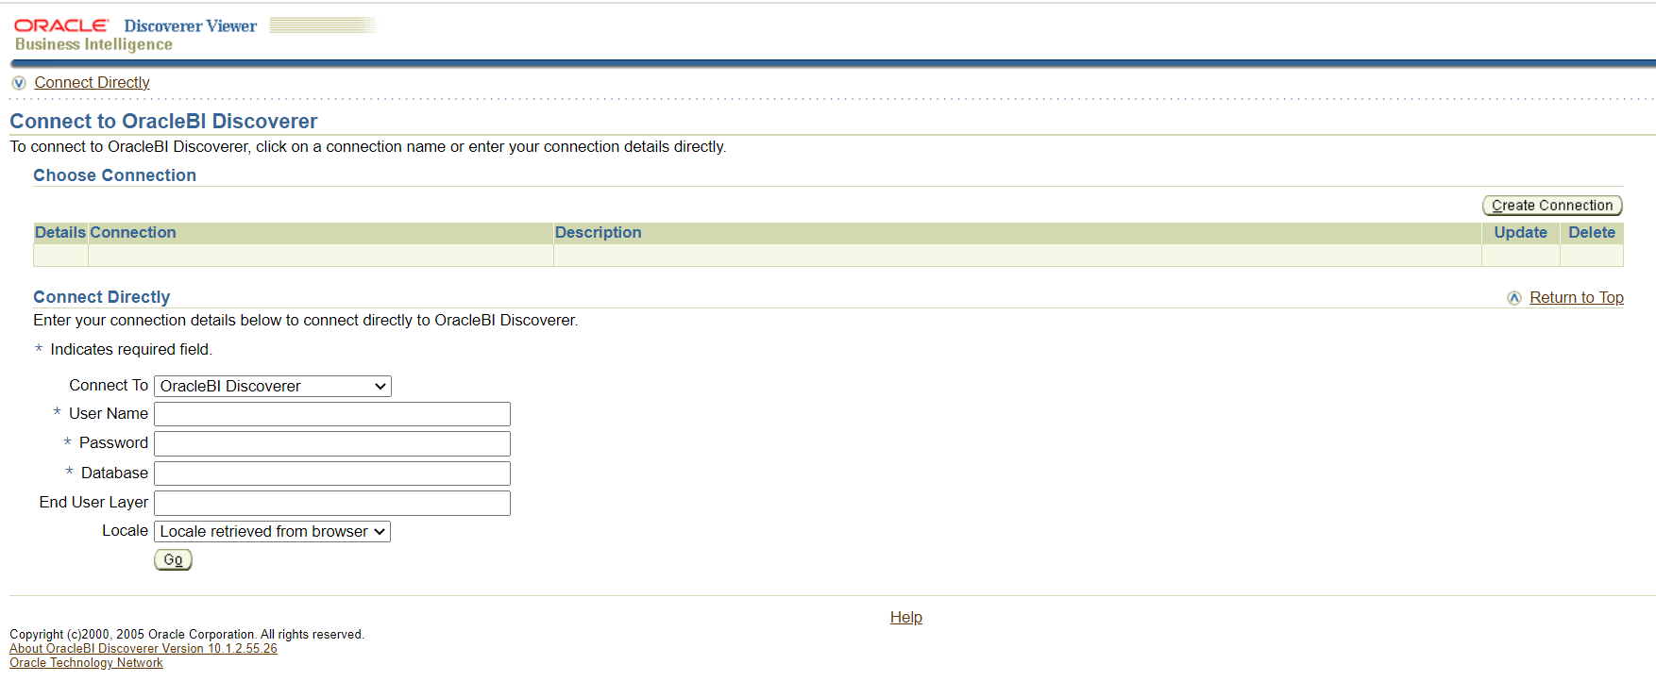
I put user name, pwd and database and go it’s navigating for a long time :

23/08/31 15:44:39 [4] [libopmnwc] Process Ping Failed: WebCache~WebCache~WebCache~1 (341092518:8999) [The connection SSL receive timed out]
23/08/31 15:45:29 [4] [libopmnwc] Process Ping Failed: WebCache~WebCache~WebCache~1 (341092518:8999) [The connection SSL receive timed out]
23/08/31 15:46:19 [4] [libopmnwc] Process Ping Failed: WebCache~WebCache~WebCache~1 (341092518:8999) [The connection SSL receive timed out]
23/08/31 15:46:19 [4] [libopmnwc] Process Unreachable: WebCache~WebCache~WebCache~1 (341092518:8999)
23/08/31 15:46:21 [4] Stopping Process: WebCache~WebCache~WebCache~1 (341092518:8999)
23/08/31 15:46:37 [4] Starting Process: WebCache~WebCache~WebCache~1 (341092518:0)
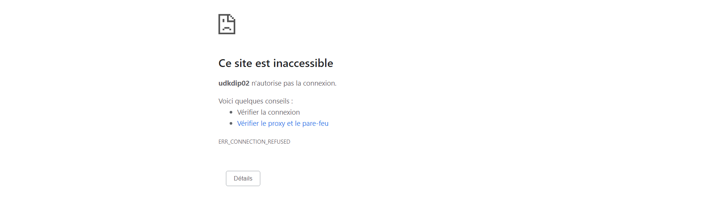

I reactualize the page again and than it continue navigating …
23/08/31 15:46:37 [4] Starting Process: WebCache~WebCache~WebCache~1 (341092518:0)
23/08/31 15:46:37 [4] Process Alive: WebCache~WebCache~WebCache~1 (341092518:9393)
23/08/31 15:48:27 [4] [libopmnwc] Process Ping Failed: WebCache~WebCache~WebCache~1 (341092518:9393) [The connection SSL receive timed out]

