CM1 specialization Rules
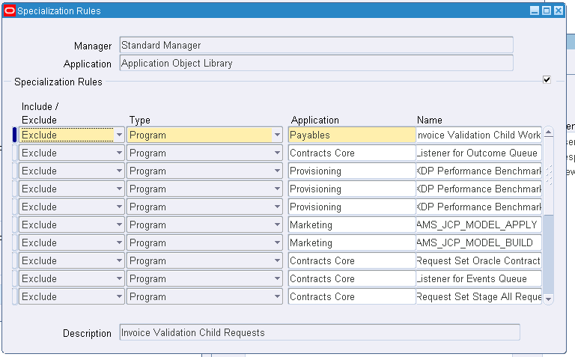
next
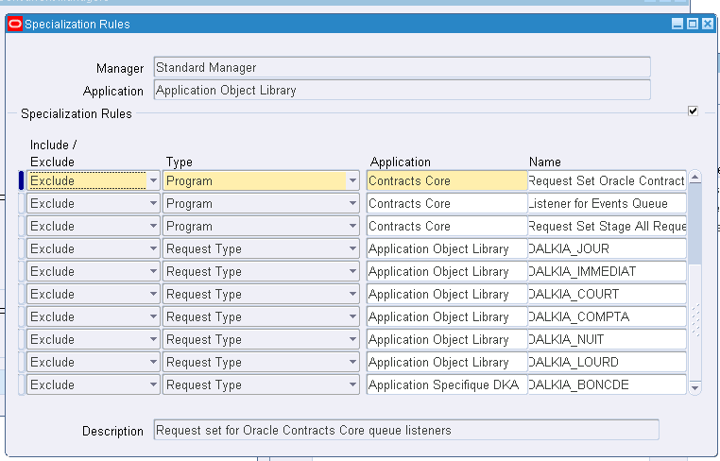

CM2 specialization Rules

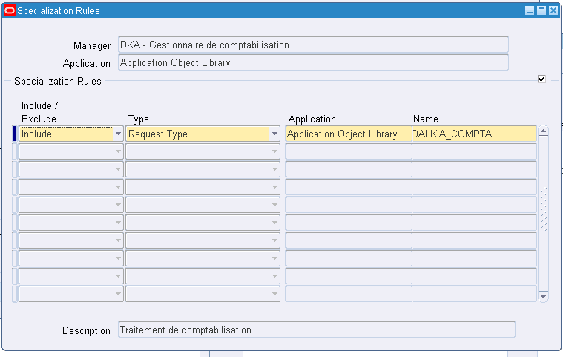

As we can see, both of them can do request type: DALKIA_COMPTA.

From the backend:

SQL> select 'Concurrent program '||fcp.concurrent_program_name||' is '||decode(fcqc.include_flag,'I','included in ','E','excluded from ')||fcqv.user_concurrent_queue_name specialization_rule_details from fnd_concurrent_queues_vl fcqv,fnd_concurrent_queue_content fcqc,fnd_concurrent_programs fcp where fcqv.concurrent_queue_id=fcqc.concurrent_queue_id and fcqc.type_id=fcp.concurrent_program_id and fcp.concurrent_program_name='DALKIA_COMPTA';

no rows selected

- However, how can CM2 run CM1’s requests as we have no rules defined for that?
- They take long time to finish

